# HTML and CSS

To get started with HTML and CSS, please see following videos.

1. <https://www.youtube.com/watch?v=OZeoiotzPFg>
2. <https://www.youtube.com/watch?v=yyqvXhu-HOc>

## HTML Task

1. What is HTML? Give basic structure of the HTML page.

**Ans.** HTML stands for HyperText Markup Language. It is used to design web pages using a markup language. HTML is a combination of Hypertext and Markup language. Hypertext defines the link between web pages. A markup language is used to define the text document within the tag which defines the structure of web pages. This language is used to annotate (make notes for the computer) text so that a machine can understand it and manipulate text accordingly. Most markup languages (e.g. HTML) are human-readable.

HTML Page Structure:

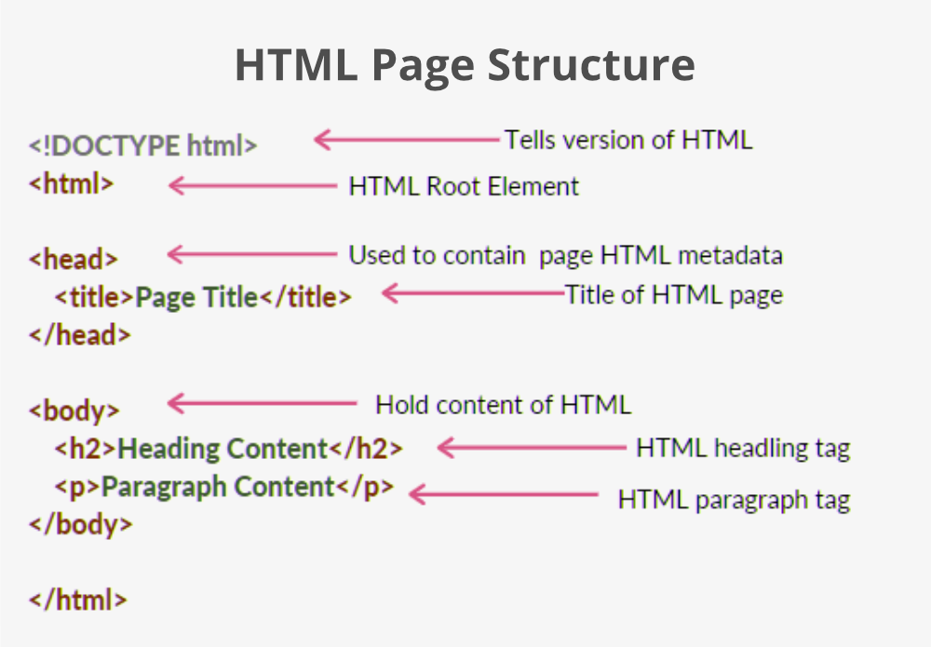

1. <!DOCTYPE html>: This is the document type declaration (not technically a tag). It declares a document as being an HTML document. The doctype declaration is not case-sensitive.
2. <html>: This is called the HTML root element. All other elements are contained within it.
3. <head>: The head tag contains the “behind the scenes” elements for a webpage. Elements within the head aren’t visible on the front-end of a webpage. HTML elements used inside the <head> element include:

* <style>-This html tag allows us to insert styling into our webpages and make them appealing to look at with the help of CSS.
* <title>-The title is what is displayed on the top of your browser when you visit a website and contains the title of the webpage that you are viewing.
* <base>-It specifies the base URL for all relative URL’s in a document.
* <noscript>– Defines a section of HTML that is inserted when the scripting has been turned off in the users browser.
* <script>-This tag is used to add functionality in the website with the help of JavaScript.
* <meta>-This tag encloses the meta data of the website that must be loaded every time the website is visited. For eg:- the metadata charset allows you to use the standard UTF-8 encoding in your website. This in turn allows the users to view your webpage in the language of their choice. It is a self-closing tag.
* <link>– The ‘link’ tag is used to tie together HTML, CSS, and JavaScript. It is self-closing.

1. <body>: The body tag is used to enclose all the visible content of a webpage. In other words, the body content is what the browser will show on the front-end.
2. Difference between inline and block level element.

**Ans.** Following are the differences between inline and block level elements.

1. Block elements always start on a new line, while Inline elements do not start on a new line.
2. Block elements cover the entire available width, while inline elements only take up the required space.
3. Block elements have top and bottom margin, while inline elements do not have top and bottom margin.
4. Inline elements allow other inline elements to take up the neighboring space, while block elements covers the entire available width.
5. Commonly used block elements are <p>, heading tags <h1>, <h2>, <h3>, <h4>, <h5>, <h6>, list tags <ul>, <ol>, <dl>, etc. and commonly used inline elements are <span>, <b>, <i>, <strong>, etc.
6. Create an HTML page “index.htm” with following content.

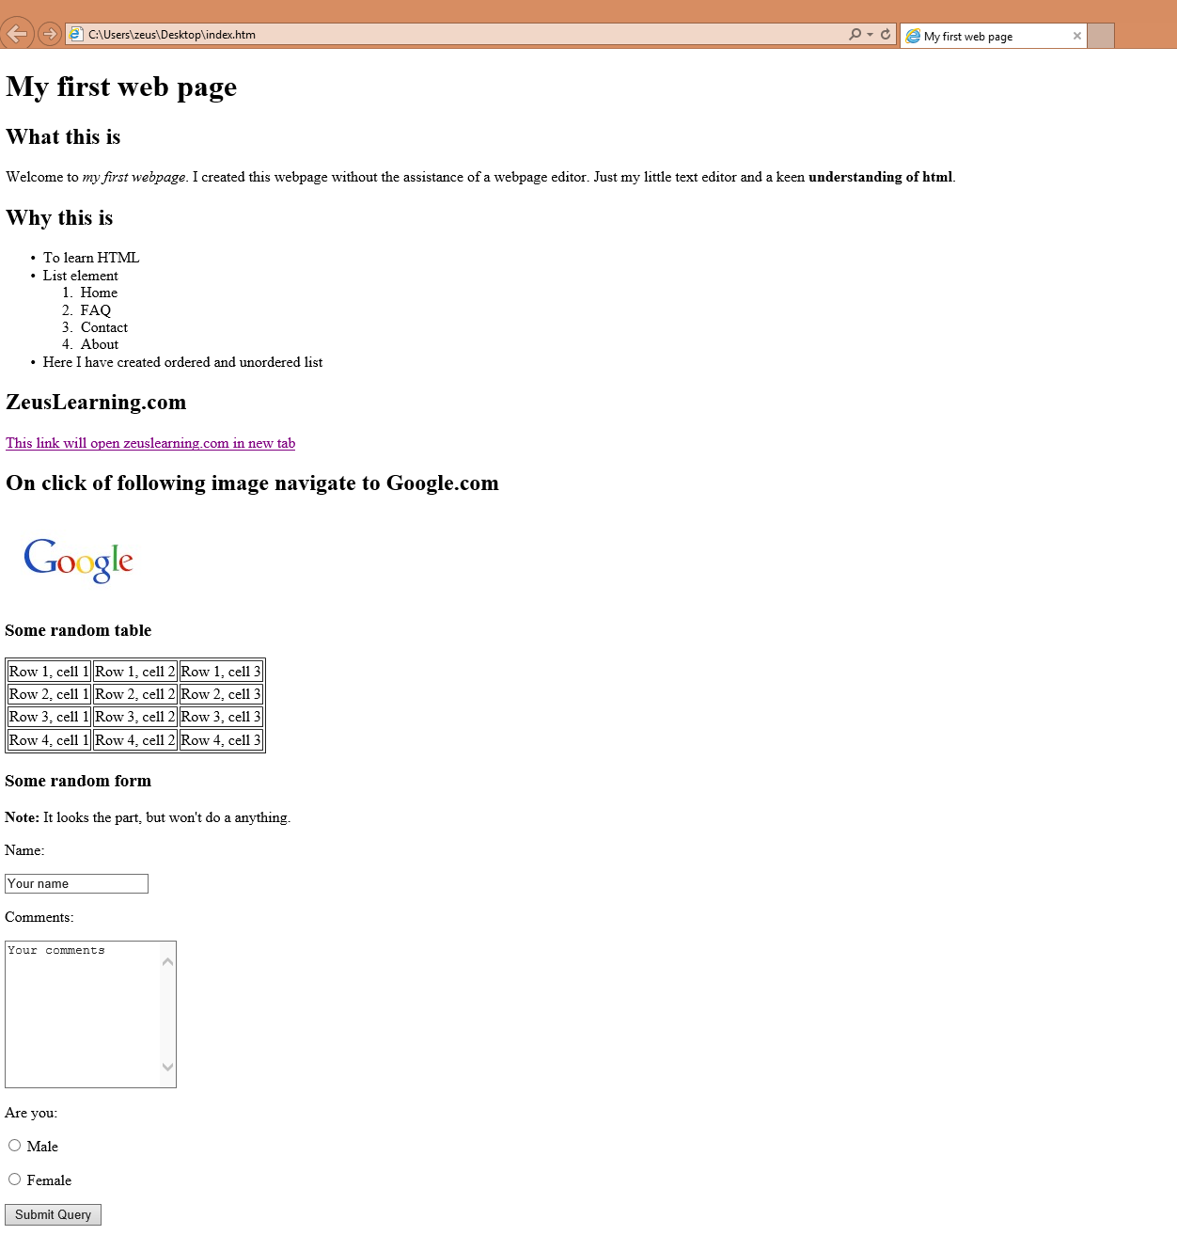

## CSS Task

1. Explain the different ways in which CSS can be applied to HTML, what is the preferred way and why.

**Ans.** CSS can be applied to HTML using the following ways:

1. Inline CSS: Inline CSS can be applied using the style attribute in the HTML elements.
2. Internal CSS: Internal CSS can be applied using the <style> element in the <head> section.
3. External CSS: External CSS can be applied by linking an external style sheet to the HTML document by using <link> element in the <head> section.

The preferred way of applying CSS to HTML is External CSS, but it can also depend on the requirement:

1. To apply a particular style to a single HTML element we can use inline CSS.
2. To style a single HTML page having many HTML elements, we can use internal CSS.
3. An external style sheet is used to define the style for many HTML pages.
4. What are different CSS selectors, with example explain Element, Class and Id selectors.

**Ans.** CSS selectors are used to "find" (or select) the HTML elements you want to style.

There are different types of CSS selectors such as:

1. Element Selector
2. Id Selector
3. Class Selector
4. Universal Selector
5. Group Selector
6. Attribute Selector
7. Pseudo-Class Selector
8. Pseudo-Element Selector

We will apply CSS rules to the below HTML code.

<!DOCTYPE html>

<html lang="en">

<head>

    <link rel="stylesheet" href="style.css">

</head>

<body>

    <h1>

        Sample Heading

    </h1>

    <p>

        Lorem ipsum dolor sit amet. Et ducimus dignissimos nam ipsum sunt ea earum explicabo? Id maiores assumenda est autem enim et deleniti molestiae aut laboriosam corporis id nisi sapiente.

        Ut harum voluptatem et dolores praesentium et iste beatae aut aliquid maxime sed doloribus dolor est placeat eveniet. Aut voluptatem repellendus sed similique voluptates aut temporibus rerum ut similique eius est nulla deleniti? Et dolor nisi a quisquam quae 33 Quis pariatur.

        Eos omnis perspiciatis et atque molestiae et minima facere. Quo totam facilis ut sunt optio est voluptas nemo 33 molestias beatae et vero temporibus aut vitae praesentium.

    </p>

    <div id="div-container">

        Lorem ipsum dolor sit amet. Et ducimus dignissimos nam ipsum sunt ea earum explicabo? Id maiores assumenda est autem enim et deleniti molestiae aut laboriosam corporis id nisi sapiente.

        Ut harum voluptatem et dolores praesentium et iste beatae aut aliquid maxime sed doloribus dolor est placeat eveniet. Aut voluptatem repellendus sed similique voluptates aut temporibus rerum ut similique eius est nulla deleniti? Et dolor nisi a quisquam quae 33 Quis pariatur.

        Eos omnis perspiciatis et atque molestiae et minima facere. Quo totam facilis ut sunt optio est voluptas nemo 33 molestias beatae et vero temporibus aut vitae praesentium..

    </div>

    <p class="paragraph-class">

        Lorem ipsum dolor sit amet. Et ducimus dignissimos nam ipsum sunt ea earum explicabo? Id maiores assumenda est autem enim et deleniti molestiae aut laboriosam corporis id nisi sapiente.

        Ut harum voluptatem et dolores praesentium et iste beatae aut aliquid maxime sed doloribus dolor est placeat eveniet. Aut voluptatem repellendus sed similique voluptates aut temporibus rerum ut similique eius est nulla deleniti? Et dolor nisi a quisquam quae 33 Quis pariatur.

        Eos omnis perspiciatis et atque molestiae et minima facere. Quo totam facilis ut sunt optio est voluptas nemo 33 molestias beatae et vero temporibus aut vitae praesentium.

    </p>

    <a href="#">Learn HTML</a>

    <a href="#">Learn CSS</a>

    <a href="#">Learn Javascript</a>

</body>

</html>

**Element selector:** The element selector selects HTML elements based on the element name (or tag) for example p, h1, div, span, etc.

h1 {

    color: red;

    font-size: 3rem;

}

p {

    color: white;

    background-color: gray;

}

**Id selector:** The id selector uses the id attribute of an HTML element to select a specific element.

#div-container{

    color: blue;

    background-color: gray;

}

**Class-selector:** The class selector selects HTML elements with a specific class attribute.

.paragraph-class {

    color:white;

    font-family: monospace;

    background-color: purple;

}

**Universal-selector:** The Universal selector (*) in CSS is used to select all the elements in an HTML document. It also includes other elements which are inside under another element.

* {

    color: white;

    background-color: black;

}

**Group-selector:** This selector is used to style all comma-separated elements with the same style.

#div-container, .paragraph-class, h1{

    color: white;

    background-color: purple;

    font-family: monospace;

}

**Attribute Selector:** The attribute selector [attribute] is used to select the elements with a specified attribute or attribute value.

[href] {

    background-color: lightgreen;

    color: black;

    font-family: monospace;

    font-size: 1rem;

}

**Pseudo-Class Selector:** It is used to style a special type of state of any element. For example- It is used to style an element when a mouse cursor hovers over it.

h1:hover{

    background-color: aqua;

}

**Pseudo-Element Selector:** It is used to style any specific part of the element. For Example- It is used to style the first letter or the first line of any element.

p::first-line{

    background-color: goldenrod;

}

1. With the help of a diagram explain CSS Box Model.

**Ans.** CSS Box Model:

In CSS, the term "box model" is used when talking about design and layout. The CSS box model is essentially a box that wraps around every HTML element. It can be used as a toolkit for customizing the layout of different elements. The web browser renders every element as a rectangular box according to the CSS box model. It consists of margins, borders, padding, and the actual content.

* content: This contains the actual data in the form of text, images, or other media forms and it can be sized using the [width & height](https://www.geeksforgeeks.org/css-height-and-width/) property.
* [padding](https://www.geeksforgeeks.org/css-margins-padding/): This property is used to create space around the element, inside any defined border.
* [border](https://www.geeksforgeeks.org/css-borders/): This property is used to cover the content & any padding, & also allows setting the style, color, and width of the border.
* [margin](https://www.geeksforgeeks.org/css-margins-padding/): This property is used to create space around the element ie., around the border area.

The box model allows us to add a border around elements, and to define space between elements.

1. To HTML page create in the task 1.a, apply following CSS.

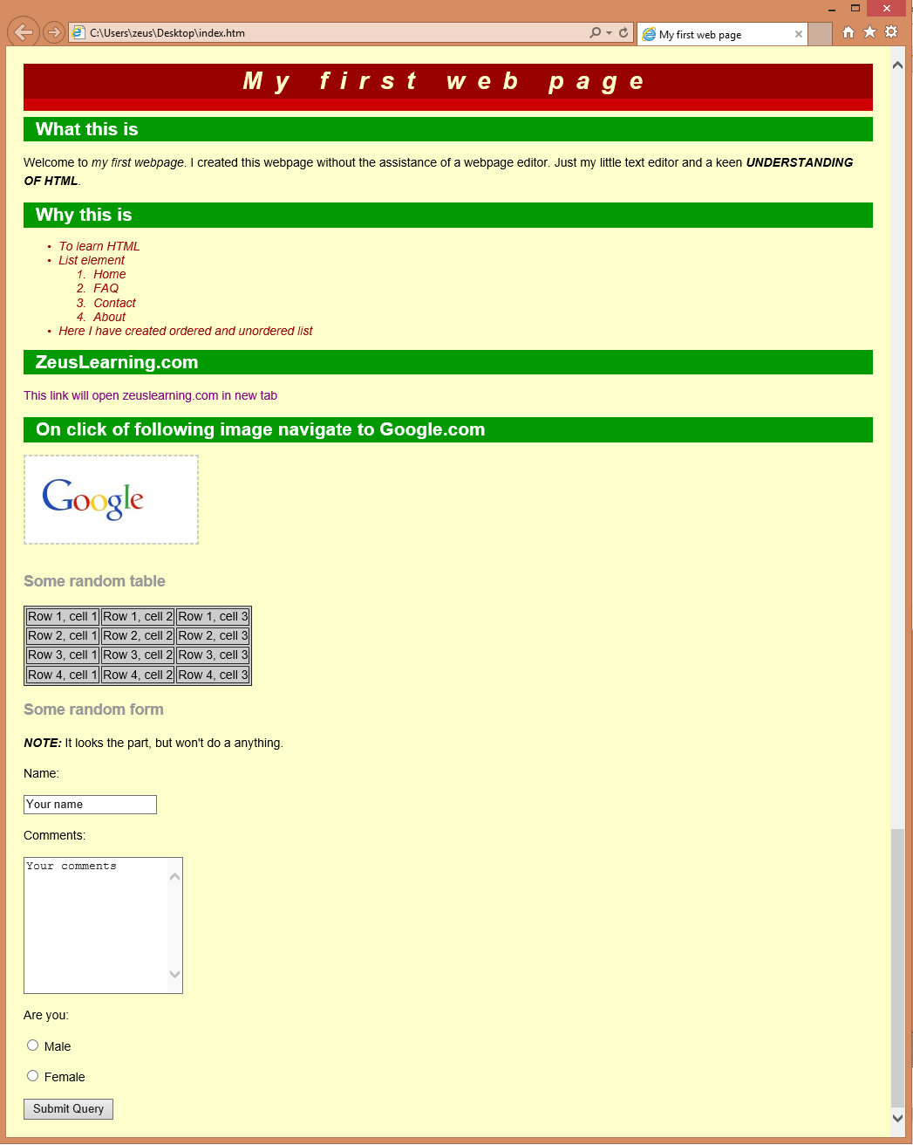

# JavaScript

1. List down ways in which JavaScript command can be added to a webpage, what is the preferred way.

Following methods can be used to add JavaScript command to a webpage:

**I. Embedding code: -**

To add the JavaScript code into the HTML pages, we can use the <script>.....</script> tag of the HTML that wrap around JavaScript code inside the HTML program. Users can also define JavaScript code in the [<body> tag](https://www.javatpoint.com/html-body-tag) (or we can say body section) or [<head> tag](https://www.javatpoint.com/html-head) because it completely depends on the structure of the web page that the users use.

**II. Inline code:-**

Generally, this method is used when we have to call a function in the HTML event attributes. There are many cases (or events) in which we have to add JavaScript code directly eg., OnMover event, OnClick, etc.

**III. External file:-**

We can also create a separate file to hold the code of JavaScript with the (.js) extension and later incorporate/include it into our HTML document using the **src** attribute of the <script> tag.

**Preferred way:**

Using an External file to add JavaScript command is an ideal way. It is very helpful if we want to use the same code in multiple HTML documents. It also saves us from the task of writing the same code repeatedly and makes it easier to maintain web pages.

1. To the webpage created in the task 2.d , on click of “Submit” button call JavaScript function to validate:
   1. Name and comments fields are not empty.
   2. User has selected one entry from male/female radio button
   3. In case user has not entered data for name and comment field or not selected anything from male/female radio button – show alert message “All fields are compulsory” and set focus to the first filed that is empty.